Change request: 07/11/20

1. **Shadow topic name change:**

* Shadow Publish topic name will be changed from

**Old Publish Topic:** $aws/things/Assetxxxx /shadow/update

**New Publish Topic:** $aws/things/Assetxxxx/shadow/name/Custxxxx/update

* Shadow subscribe topic name will be changed from

**Old subscribe Topic:** $aws/things/Assetxxxx /shadow/update/accepted

**New subscribe Topic:** $aws/things/Assetxxxx/shadow/name/Custxxxx/update/accepted

* Get Shadow Publish topic name will be changed from

**Old Publish Topic:** $aws/things/Assetxxxx /shadow/get

**New Publish Topic:** $aws/things/Assetxxxx/shadow/name/Custxxxx/get

* Get Shadow subscribe topic name will be changed to

**Old subscribe Topic:** $aws/things/Assetxxxx /shadow/get/accepted

**New subscribe Topic:** $aws/things/Assetxxxx/shadow/name/Custxxxx/get/accepted

1. **Live On Logic change:**
   1. **Change : 1:**

**Old logic:**

LiveON = “on” was published on log in by customer or users and also published when any new Asset is connected

**New Logic:**

LiveOn will not be published during logging time or on connected event.

* 1. **Change:2:**

Now LiveOn=”on” be published on clicking the respective asset in the dashboard page where list of assets shown. Now Liveon will be published only for the respective assets through the shadow topic.

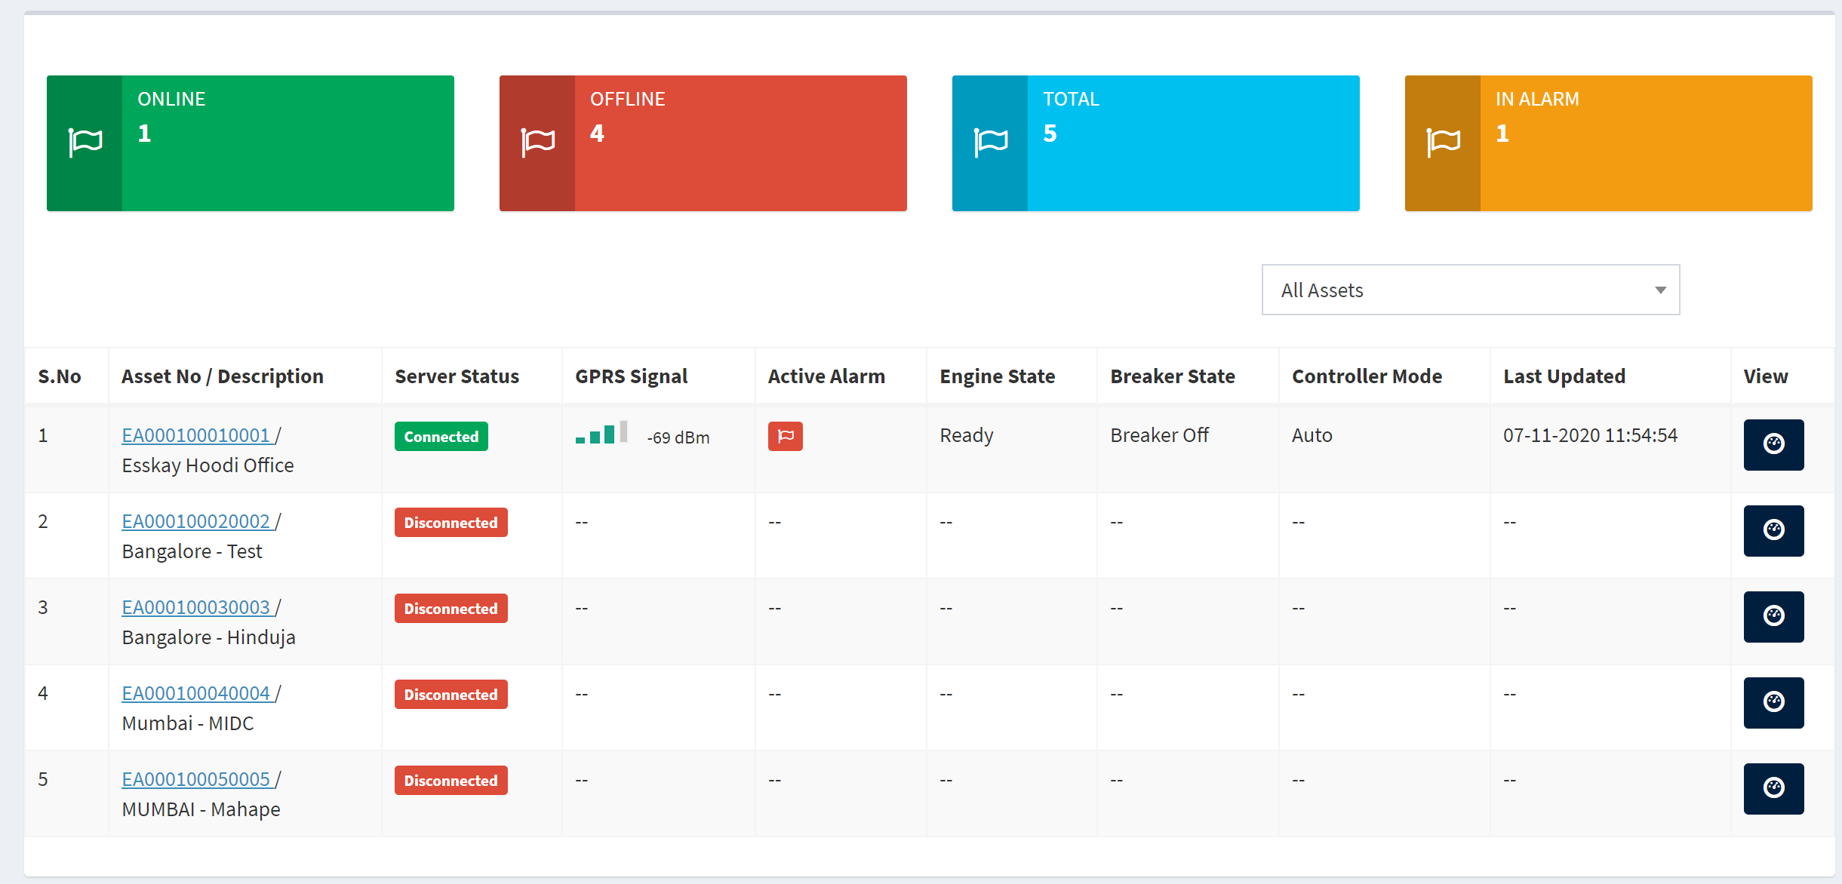



By clicking this button it should publish liveon = “on” to shadow topic

* 1. **Topic name to publish liveon will be:** $aws/things/Assetxxxx/shadow/name/Custxxxx/update

Live on introduced in Shadow under new key value “DP15”. The Json file should be as below to Liveon.

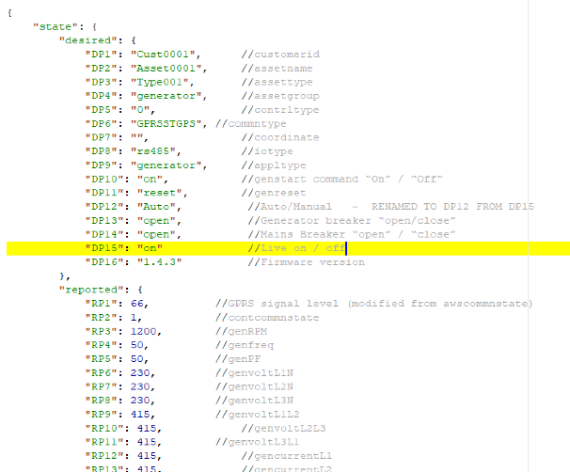{

"state": {

"desired": {

"DP15": "on"

}

}

}

* 1. **Live Off logic**

Liveon = “off” should not be published at all by PHP or App. IOT device will set Liveon = “off” on Liveon timeout by itself.

1. 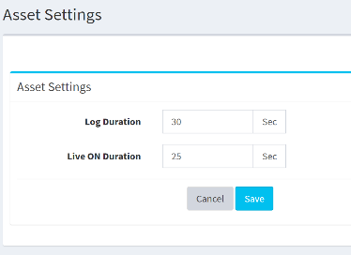**Logduration/Live duration publish**

Live On will no longer to be published under topic “Broadcast/Custxxxx”. However Live duration and Log duration to be published under “Broadcast/Custxxxx” on only when the save is pressed under Asset setting. This publish will be not required during login or connected states.

Also “Liveon Timeout” should be newly added which should be published under same topic “Broadcast/Custxxxx”. And the new Json shall look like below,

{

"BCONF0": { //Broadcast configuration message 0

"CF1":"1800", **//CF1 is modified from Liveon to Liveon Timeout**

"CF2":"30", //Live duration

"CF3":"180" //Log duration

}

}

1. **Dashboard change:**

Dashboard GPRS signal, Engine State, Breaker State, Controller mode, Last updated now should be based on “Log data” instead of “Live data”.



1. **Live data page change:**

Provide “LiveOn” / “LiveOff” indication this page. Additionally provide a button for LiveOn publish.

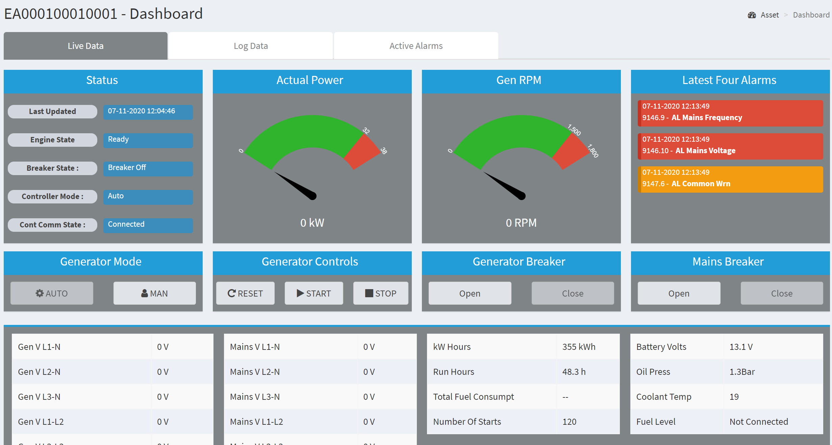

1. **Shadow Creation at the time New Asset/Thing creation:**

PHP should create shadow by publishing the below Shadow first time with the shadow name as customer name.

To create shadow follow the step,

**Publish to Topic:** $aws/things/Assetxxxx/shadow/name/Custxxxx/update

Json File: xxxx to be filled based on Asset creation parameters.

{

"state": {

"desired": {

"DP1": "Custxxxx",

"DP2": "Assetxxxx",

"DP3": "Typexxxx",

"DP4": "xxxxxxx",

"DP5": "xxxxxxx",

"DP6": "xxxxxxx",

"DP7": "xxxxxxx",

"DP8": "xxxxxxx",

"DP9": "xxxxxxx",

"DP10": "off",

"DP11": "off",

"DP12": "Manual",

"DP13": "open",

"DP14": "open",

"DP15": "off",

"DP16": "0.0.0"

},

"reported": {

"RP1": 0,

"RP2": 0,

"RP3": 0,

"RP4": 0,

"RP5": 0,

"RP6": 0,

"RP7": 0,

"RP8": 0,

"RP9": 0,

"RP10": 0,

"RP11": 0,

"RP12": 0,

"RP13": 0,

"RP14": 0,

"RP15": 0,

"RP16": 0,

"RP17": 0,

"RP18": 0,

"RP19": 0,

"RP20": 0,

"RP21": 0,

"RP22": 0,

"RP23": 0,

"RP24": 0,

"RP25": 0,

"RP26": 0,

"RP27": 0,

"RP28": 0,

"RP29": 0,

"RP30": 0,

"RP31": 0,

"RP32": 0,

"RP33": 0

}

}

}